Instructions for the use of the abstract template
Please use the provided abstract template for this year’s ISMRM Benelux meeting abstract submission. Abstracts not fulfilling the criteria of these guidelines cannot be reviewed.

- You can only send in one abstract as first author! Additional abstracts of the same first author will NOT be reviewed, so make sure to send in your finest work ONLY!

- Please enter the author list and affiliations on page 1 of the abstract template. The font of the author list and affiliations is Arial with a size of 10 pt for the author list and 8 pt for affiliations. The maximum number of lines are the following: for the author list: 2 lines, for the affiliations: 4 lines.

- Please enter the title of your abstract on page 2 of the abstract template above the blue line. The font of the abstract title is Arial with a size of 13 pt. The maximum number of lines is 2.

- Content of the abstract: please place text, figures, references and acknowledgements on page 2 of the abstract template below the blue line using the following guidelines:
  - Abstract should fit on 1 page (B4, 25.7 cm x 36.4 cm) with left, right and bottom margins of 1.25 cm and a top margin of 5.08 cm. Please note that this template already meets these criteria so do not change the margins and format size.
  - Use Times New Roman with a minimal size of 8 pt. Figure legends should also not be smaller than 8 pt.
  - Section titles (e.g. ‘Introduction’, ‘Methods’, ‘Results’, etc.) should be in bold.
  - Please submit a Microsoft Word file (.doc or .docx) during abstract submission. In addition, please export the Microsoft Word file to a Portable Document Format (PDF) file and submit the PDF file alongside with the Word file. A tutorial on how to export your Word file to PDF can be found in the next page.
  - Please use the name of the first author of the abstract as the file name, with the following format: ‘Lastname_Firstname.doc(x)’ and ‘Lastname_Firstname.pdf’.

Good luck with your submission!

How to export Word to portable document format (PDF) in Microsoft Word 2016 (Microsoft Windows users)
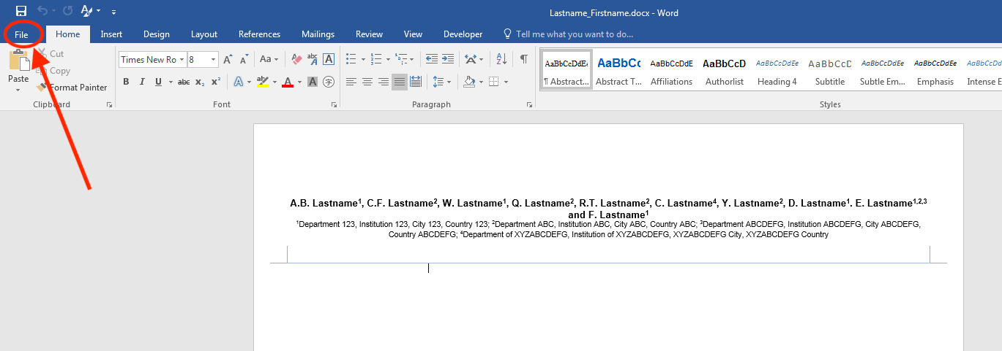
- Go to File.
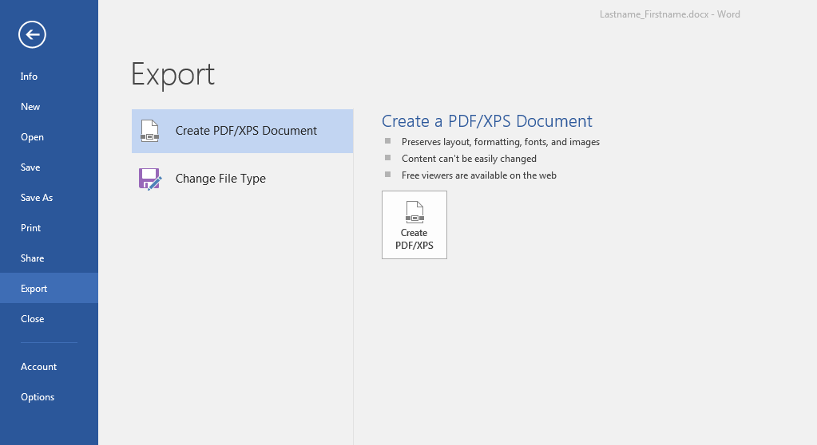
- Go to Export > Create PDF/XPS.
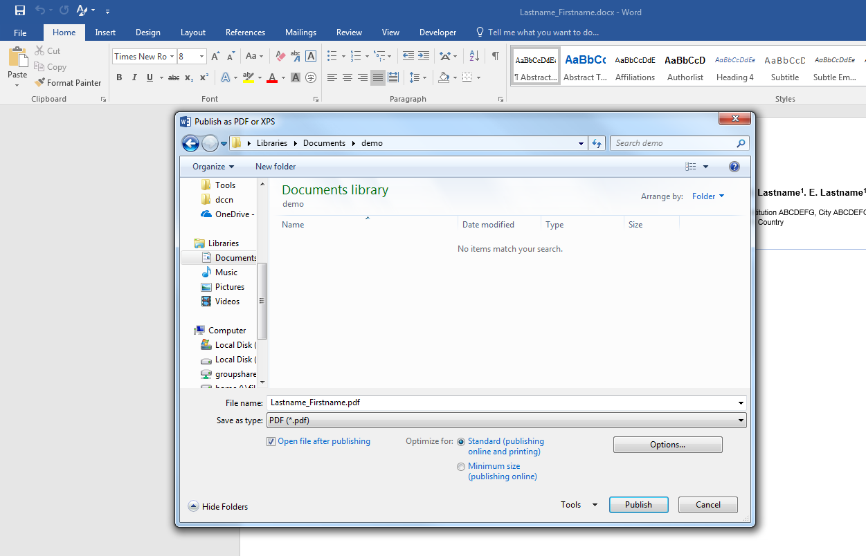
- Save as type: PDF (*.pdf) > Publish.

How to export Word to portable document format (PDF) in Microsoft Word 2016 (Mac users)
- Go to File > Click on Save As…
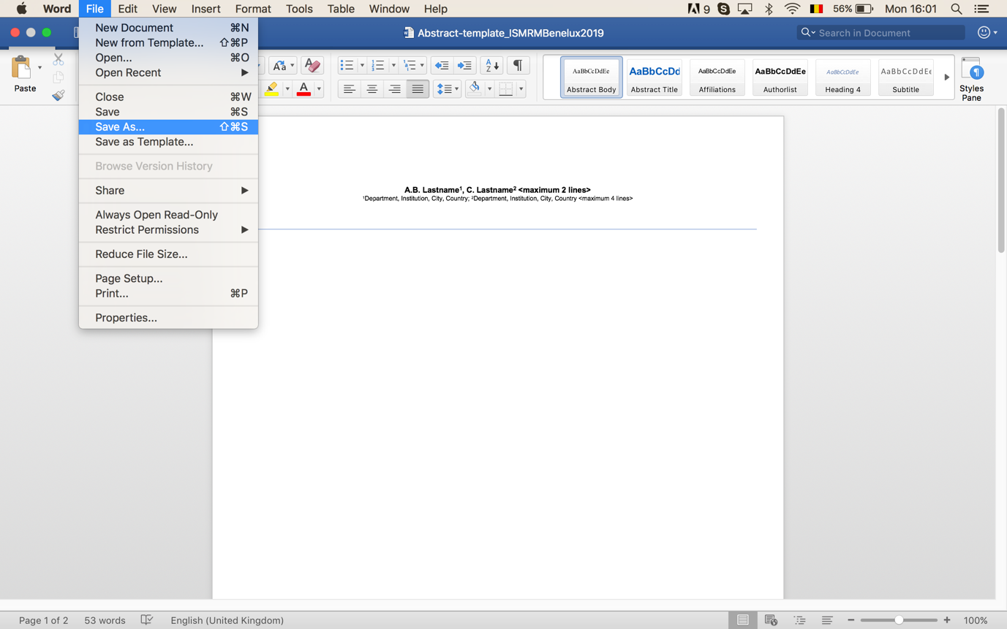
- Change File Format to PDF (under Export Formats).
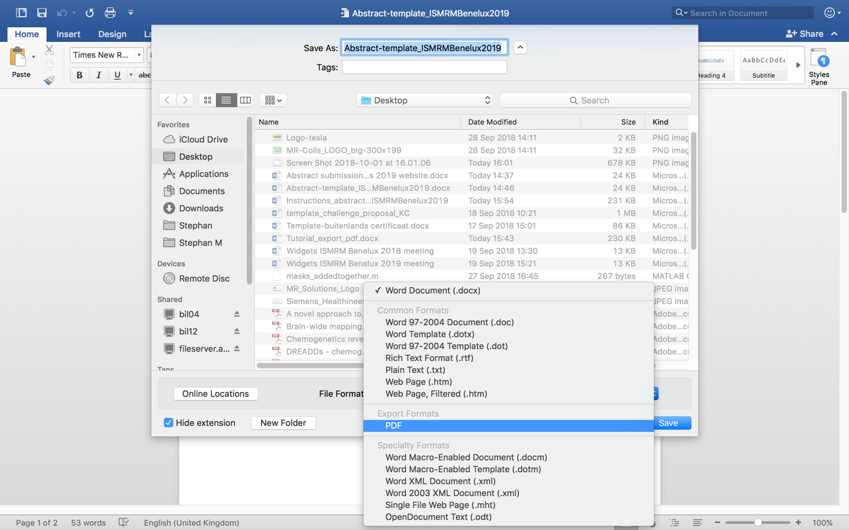
- Press Export.
